

Anekant Education Society’s

Tuljaram Chaturchand College of Arts, Science and Commerce, Baramati.

(Autonomous)

**A**

**Mini Project Report on**

**“Water Quality”**

**Submitted To**

**Department of Statistics**

**Tuljaram Chaturchand College, Baramati**

**By**

**Mr. Beldar Prasad Dattatray**

**-: Project Guide: -**

**Mrs.Nilambari Jagtap**



Anekant Education Society’s

Tuljaram Chaturchand College of Arts, Science and Commerce, Baramati. (Autonomous)

**DEPARTMENT OF STATISTICS**

**C E R T I F I C A T E**

This is to certify that Beldar Prasad Dattatray are regular students of the Department of Statistics. A Mini project on **“Water Quality**”, is submitted in partial fulfilment of the program in MSc-I to the Department of Statistics, Tuljaram Chaturchand College of Arts, Science and Commerce, Baramati.

This project has been conducted under my supervision and guidance.

Place: Baramati

Date:

Mrs Nilambari jagtap Dr. Jagtap A. S.

Project Guide Examiner Head Department of Statistics

***ACKNOWLEDGMENT***

We have satisfaction upon the completion of this project work entitled **“Water Quality”** at the Department of Statistics of “Tuljaram Chaturchand College of Arts, Science and Commerce, Baramati, during the academic year 2022-2023.

We take this opportunity to express our sense of gratitude to **Mrs. Nilambari Jagtap** for her valuable guidance and help provided us during the completion of the project.

We are very thankful to **Dr. A. S. Jagtap**, Head, Department of Statistics for providing all necessary facilities and their encouragement to do this project work.

We are thankful toall teaching staff members for their valuable cooperation during the completion of the project. We also thank all our classmates and friends at the department for their good cooperation.

Last but not the least, we would like to thank the non-teaching staff of our Department of Statistics for their cooperation regarding the lab facilities.

***INDEX***

|  |  |  |
| --- | --- | --- |
| **SR. NO.** | **TITLE** | **PAGE NO** |
| 1. | Introduction |  |
| 2. | Objectives |  |
| 3. | Methodology |  |
| 4. | Exploratory Data Analysis |  |
| 5. | Statistical Analysis |  |
| 6. | Conclusions |  |
| 7. | Scope and Limitations |  |
| 8. | References |  |

***Introduction***

India today is one of the top ten automotive markets in the world and given its burgeoning middle-class population with buying potential and steady economic growth, accelerating automotive sales is expected to continue. In the last couple of years, there has been a lot of discussion around the prices of fuel - apart from the deregulation of petrol prices. Moreover, the threat of disruption of supplies from the Middle East has heightened the debate on energy security and brought the focus on alternate drivetrain technologies. The potential for alternative technologies in automobiles such as electric vehicles (EV) in India, as in the case of many other comparable markets, depends on improved battery technologies, driving ranges, government incentives, regulations, lower prices, and better charging infrastructure.There seems to be a lot of interest on the part of Internal Combustion Engine (ICE) based manufacturers to adopt electric technology, not just supplemental to the ICE, but as a stand-alone offering. There are also specialized EV manufacturers that have come up all over the world.

While many of the factors that influence the EV market are understood intellectually, we carried out a consumer survey to study perceptions and expectations of potential for alternative technologies in automobiles such as electric vehicles (EV) and hybrid EV.

Assessing future demand for electric vehicles was somewhat challenging since it meant testing consumer preferences for a product with which they are largely unfamiliar. For this reason, we focused on uncovering consumers' familiarity with EV technologies and products; with their opinions around the price, brand, range, charging, the infrastructure, and the cost of ownership; and with the consumer's imagined "fit" of an EV in his or her lifestyle given a range of demographic parameters. Electric Vehicle (EV) is an alternative fuel vehicle that relies on electricity as an energy resource. such a large share of the automobile market will mean that there is a robust energy mix driving the cars of the future. EV is environment friendly, with tailpipe emissions, but it relies on various sources of electricity generation. For EV to be ‘green’, the electricity should be generated from renewable energy sources. The majority of today’s vehicles, power generators, and plant machinery use internal combustion engines. Due to the vast utilization of internal combustion engines in the modern world, there are growing concerns over the impact of exhaust emissions from internal combustion engines on human health and the welfare of the environment. These vehicles are powered by the burning of fossil fuels. Fossil fuels are considered non-renewable resources since they take millions of years to form. However, their reserves are being exhausted faster than they are being generated and if this trend continues, the supply would run out within the next century. The burning of fossil fuels releases carbon dioxide (CO2) emissions, a powerful greenhouse gas that vastly contributes to air pollution.

Air pollution is a major environmental concern since it increases the risk for asthma and other respiratory diseases. Furthermore, the greenhouse gases trap heat in the atmosphere which makes the Earth warmer thereby significantly influencing climate change and global warming.

***Objectives***

1. To check the association between the profession of the people and their opinions about e-vehicle.
2. To check the association between the age of the people and their opinions about e-vehicle.
3. To check the association between gender and their opinions about e-vehicle.
4. To compare the problems of e-vehicle faced by people.
5. To collect various ideas for using Electric/Hybrid Vehicles.

***Methodology***

This study seeks to discover the main factors affecting electric vehicle adoption in society. Additionally, it explored whether different characteristics impact purchasing of an electric vehicle.

**Primary data collection:**

For our project, we have used primary data. We have collected primary data through a questionnaire. We generated a google form, which had different categorical questions (different attributes like age, gender, occupation). We collected data through different areas of the city. We have in all **142 responses.**

A pilot study was conducted using 10 questionnaires to determine any flaws or weaknesses that may affect the validity of the study. The data is collected from 1 to 30 March 2022.

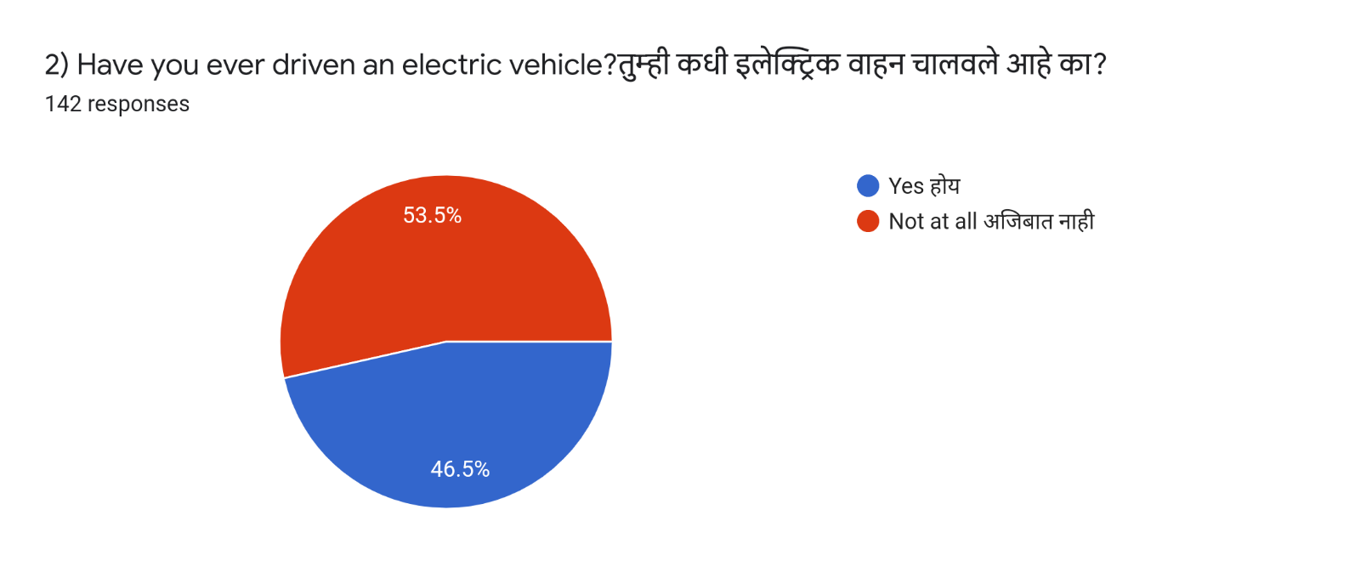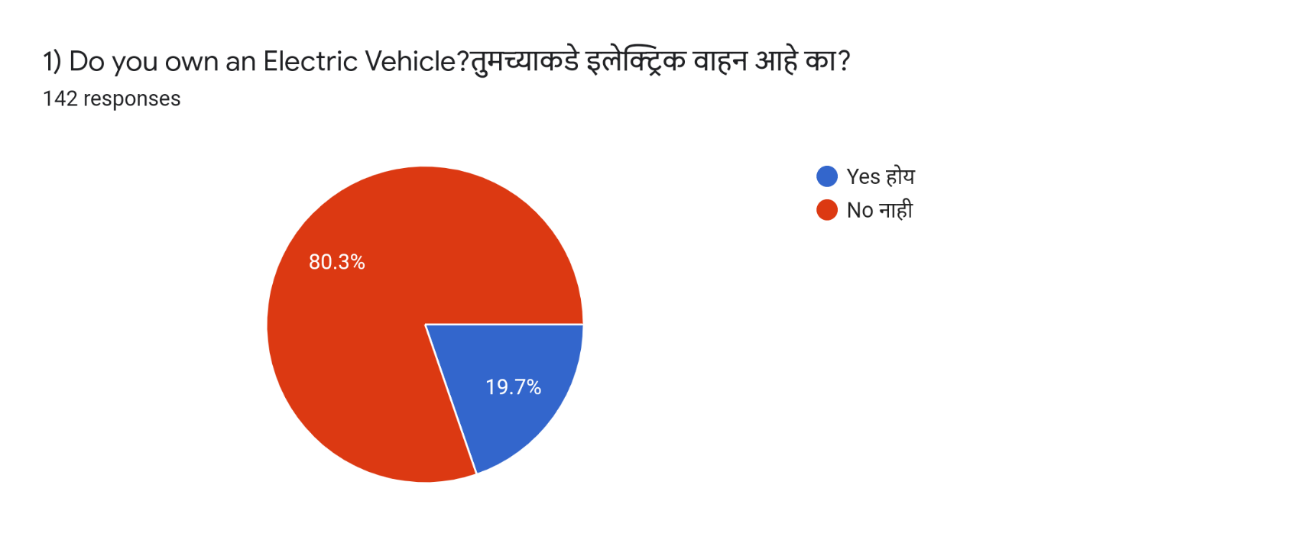***Graphical Presentation***

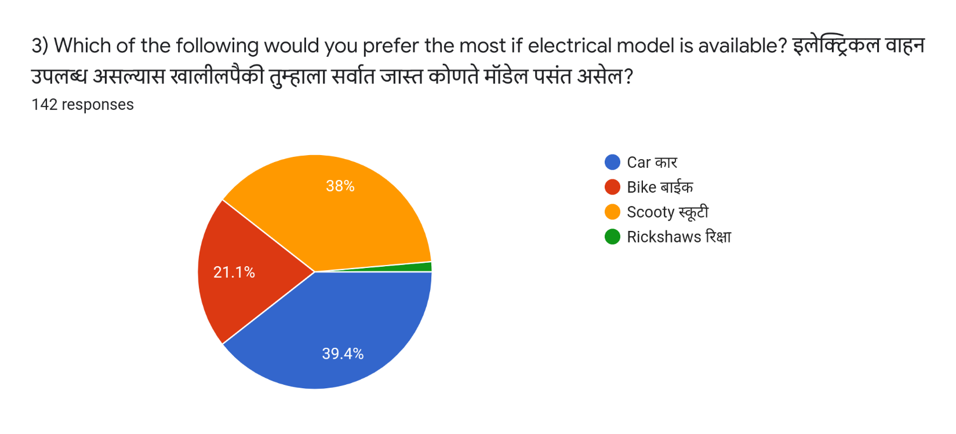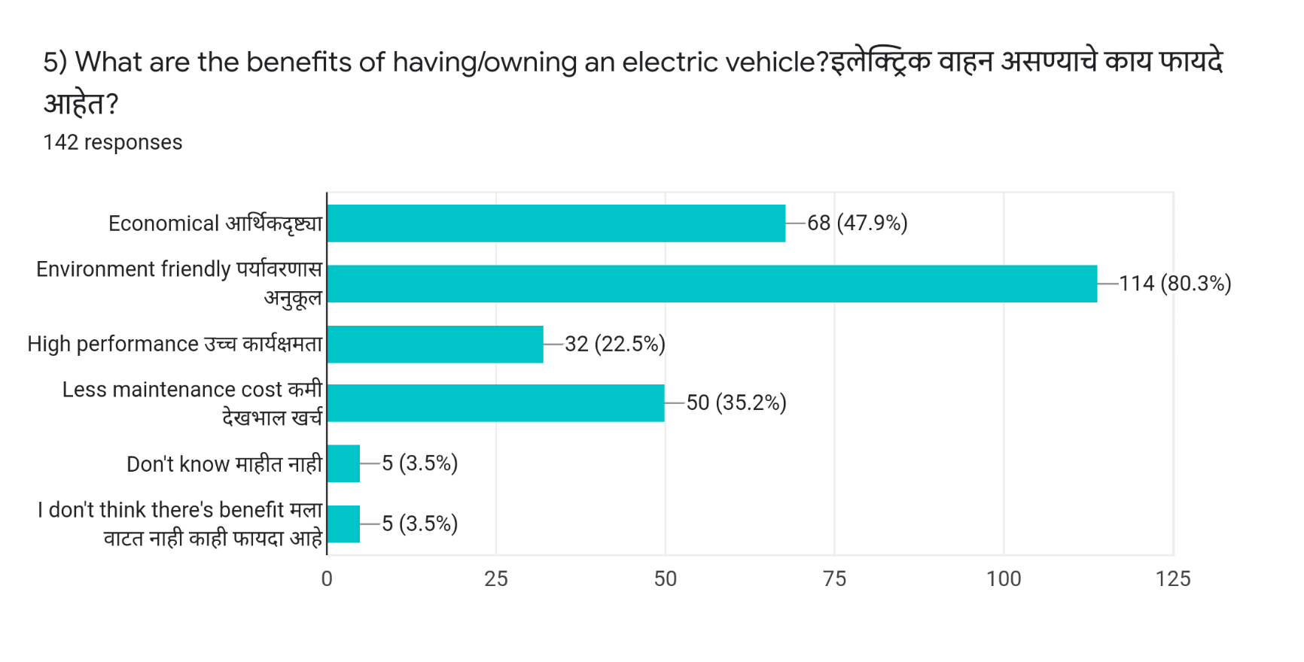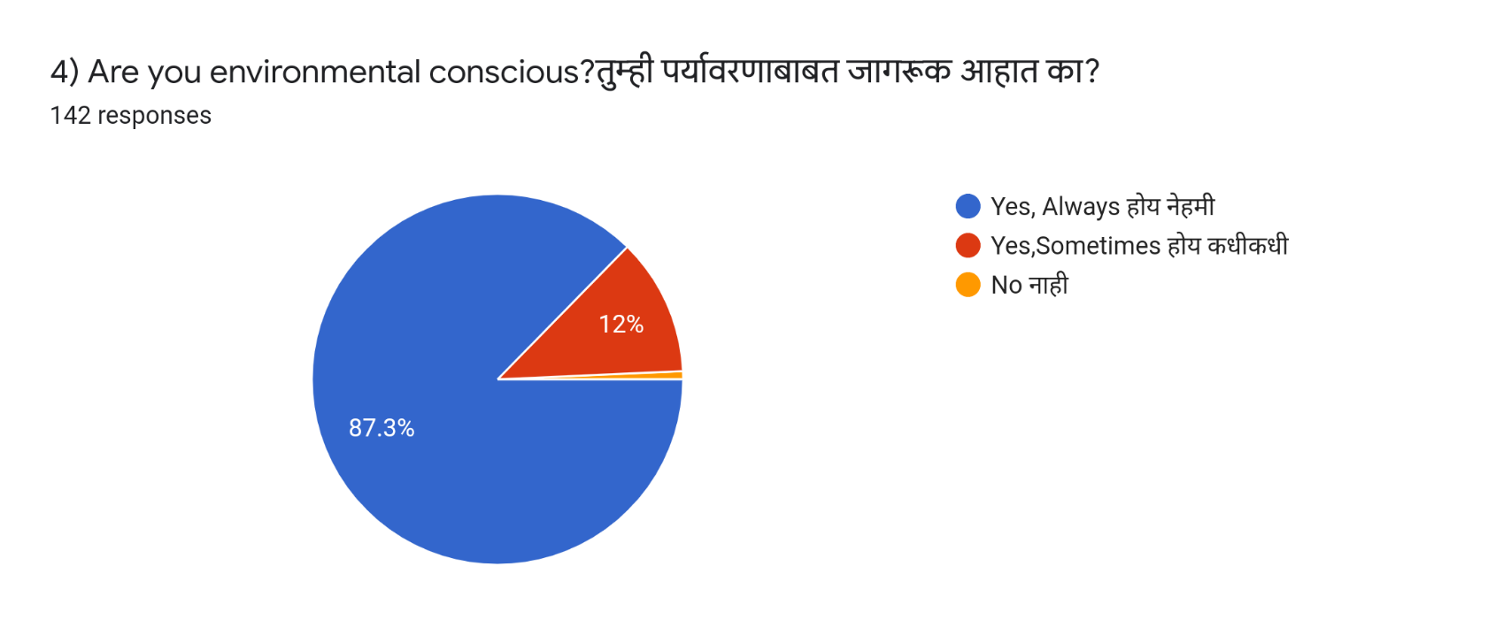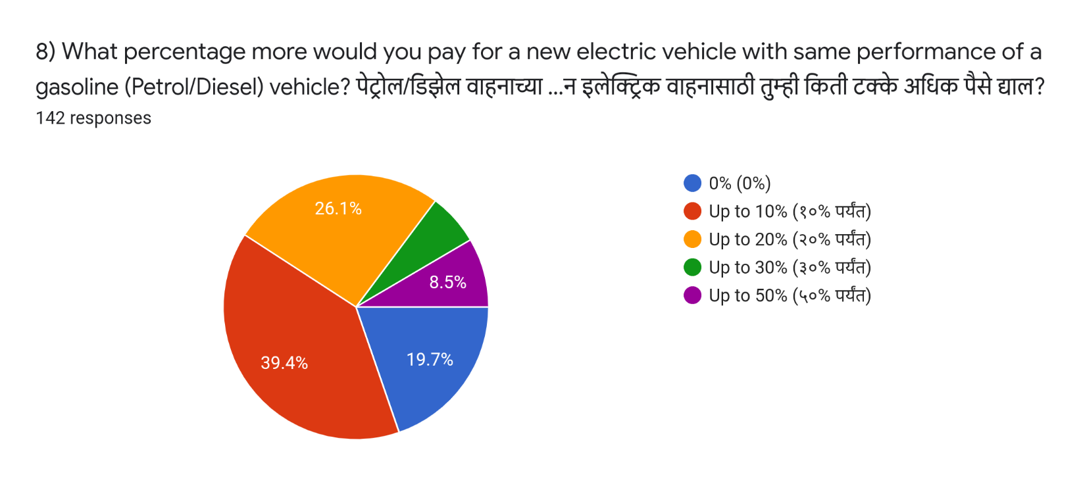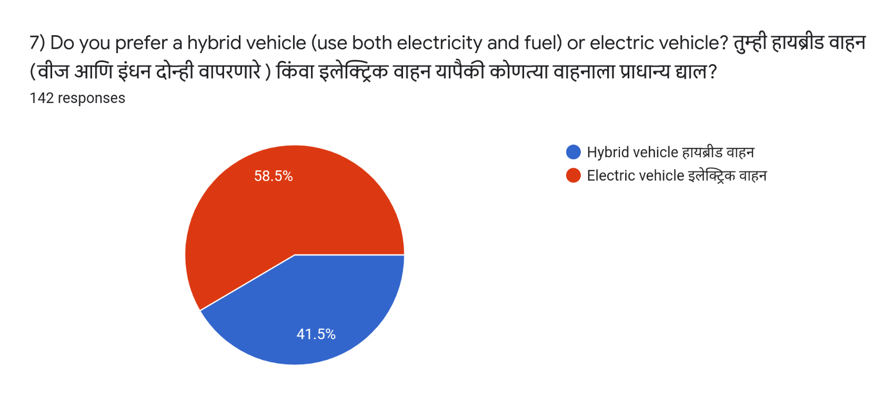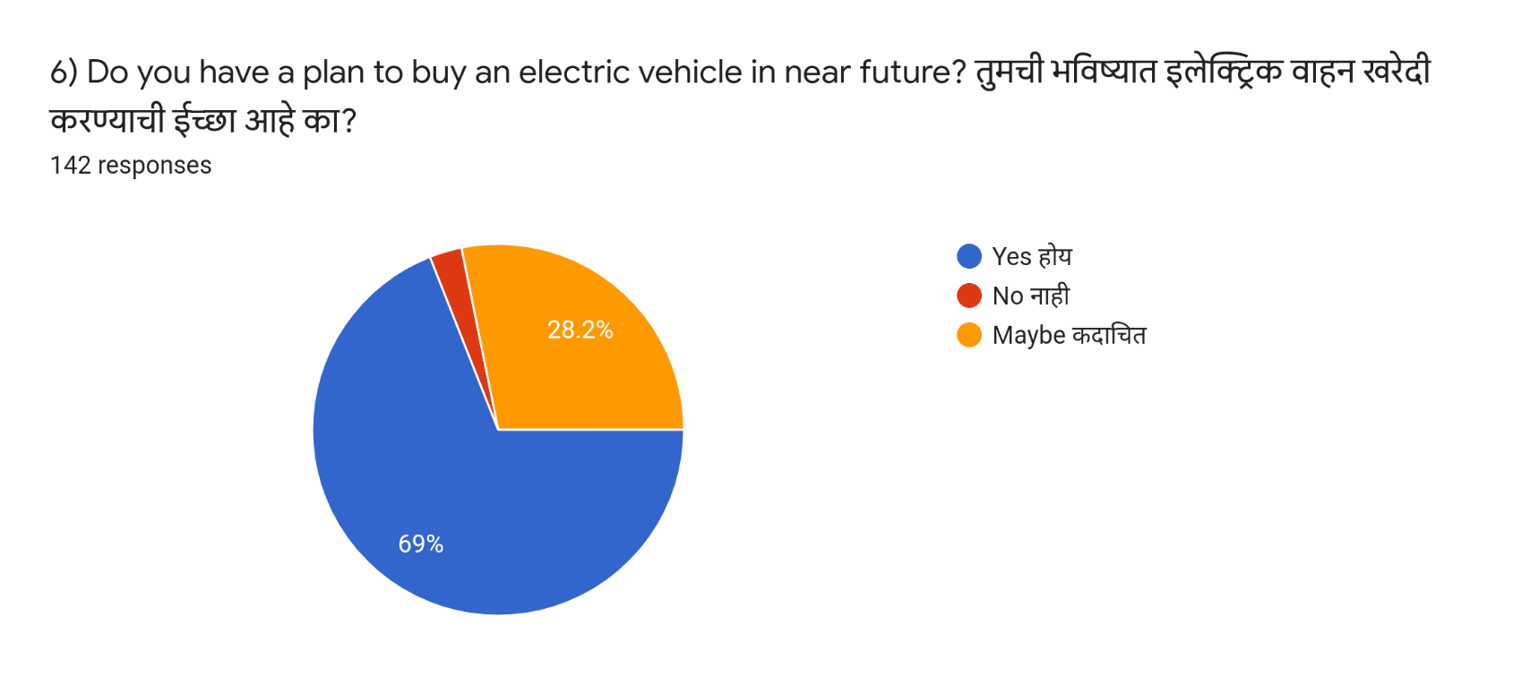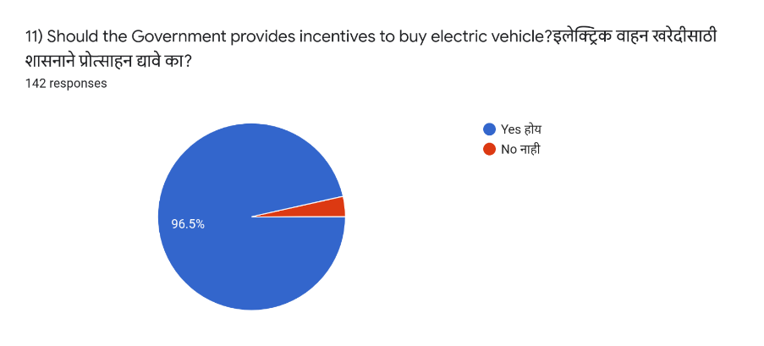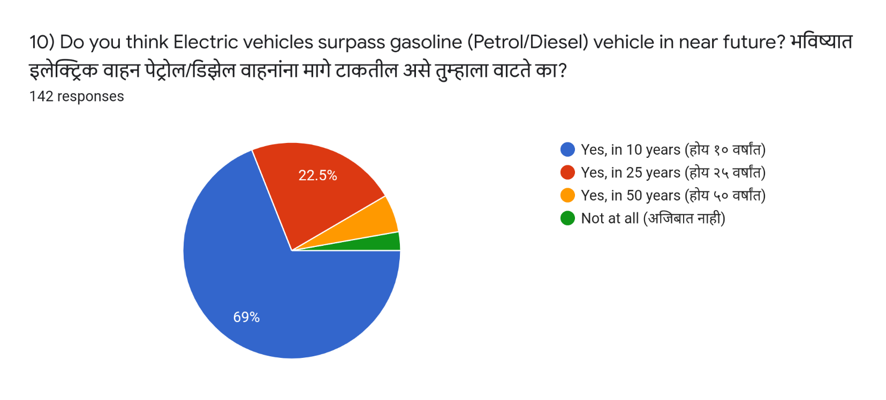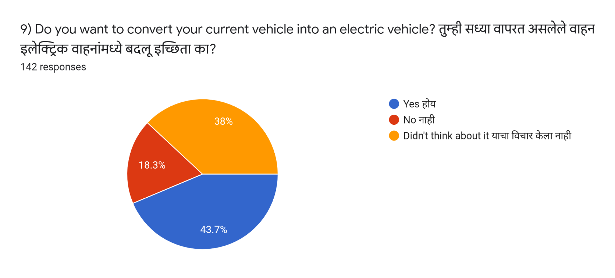

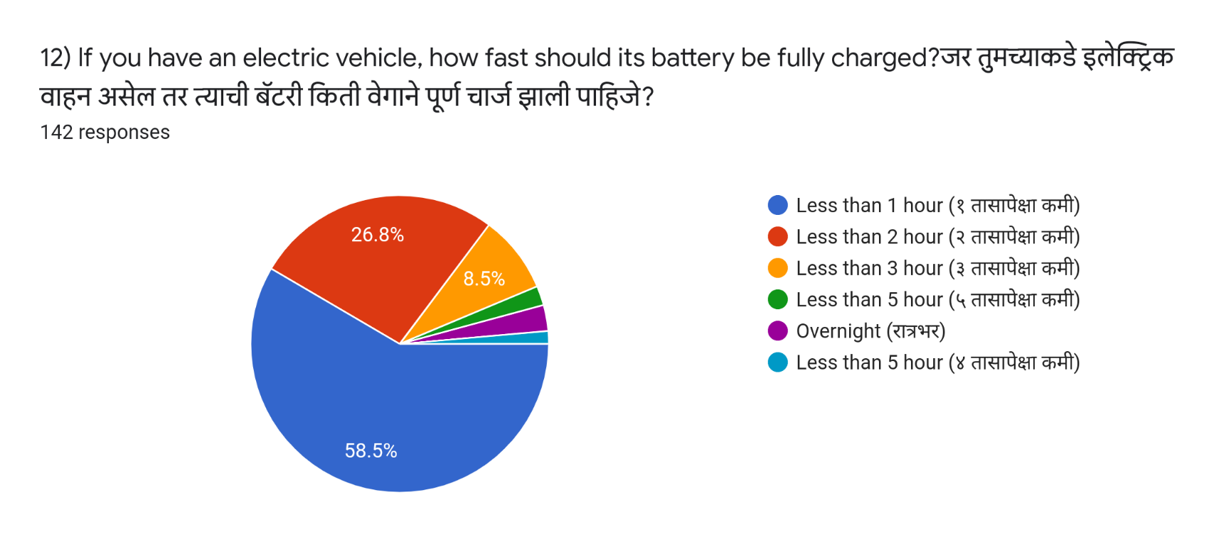

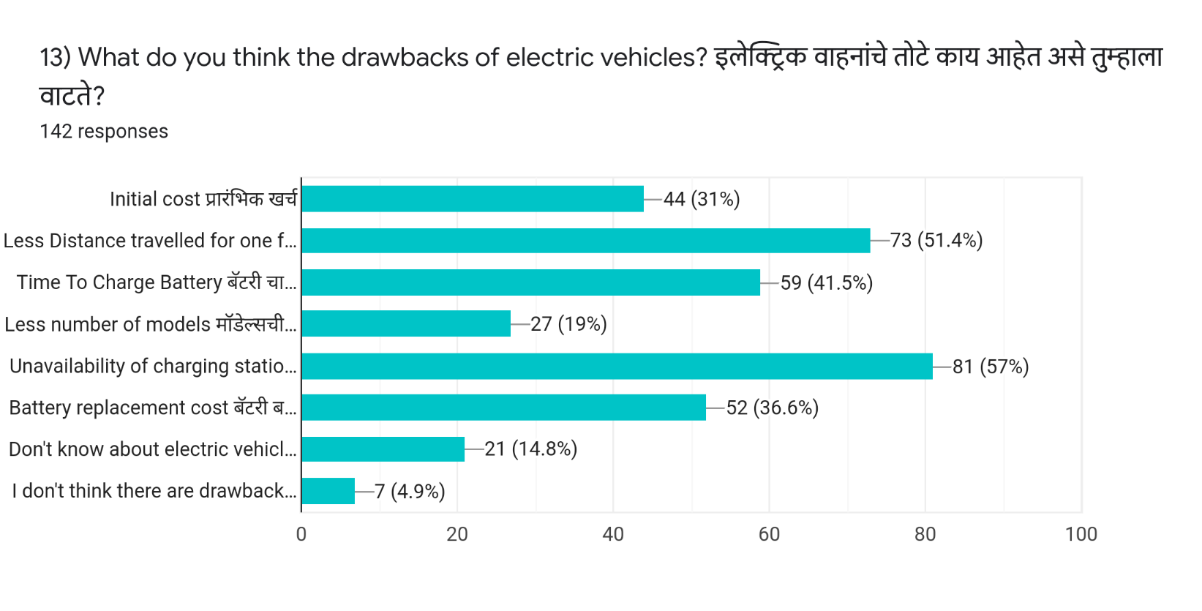

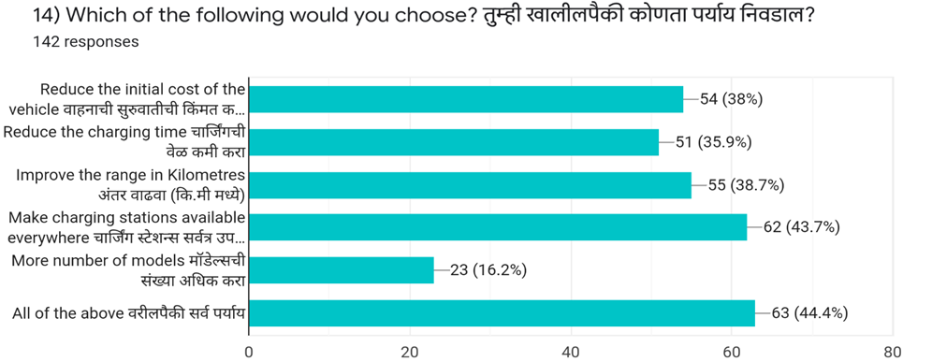

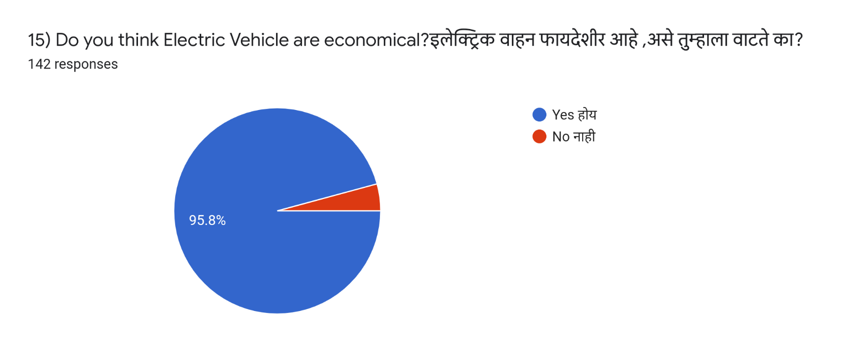

***Statistical Analysis***

**Chi-Square Test**

1. **Age Group:**

H0: Plan to buy an e-vehicle is Independent of Age

V/S

H1: Plan to buy an e-vehicle is Dependent of Age.

|  |  |  |  |  |  |  |
| --- | --- | --- | --- | --- | --- | --- |
|  | **16-24** | **25-30** | **31-40** | **41-50** | **51-60** | **60+** |
| **YES** | 63 | 18 | 13 | 2 | 2 | 0 |
| **NO** | 3 | 0 | 0 | 0 | 0 | 1 |
| **MAYBE** | 30 | 5 | 3 | 1 | 1 | 0 |

P-value = 0.08791594

Here, we may accept H0 at 5% level of significance.

**Conclusion:** We may conclude that plan to buy an e-Vehicle is Independent of Age.

**2) Gender:**

H0: Plan to buy an e-vehicle is Independent of Gender

V/S

H1: Plan to buy an e-vehicle is Dependent of Gender.

|  |  |  |
| --- | --- | --- |
|  | **MALE** | **FEMALE** |
| **YES** | 62 | 36 |
| **MAYBE** | 19 | 21 |

P-value=0.08791594

Here, we may accept H0 at 5% level of significance.

**Conclusion:** We may conclude that plan to buy an E-Vehicle is Independent of Respondent's Gender.

**3) Occupation:**

H0: Plan to buy an e-vehicle is Independent of Occupation

V/S

|  |  |  |  |  |  |  |  |  |
| --- | --- | --- | --- | --- | --- | --- | --- | --- |
|  | **OFFICE** | **EMPLOYEE** | **BUSINESS** | **FARMER** | **HOUSEWIFE** | **TEACHING STAFF** | **STUDENT** | **OTHERS** |
| **YES** | 2 | 13 | 8 | 4 | 9 | 5 | 55 | 2 |
| **NO** | 0 | 0 | 0 | 0 | 0 | 3 | 1 | 0 |
| **MAYBE** | 1 | 3 | 1 | 2 | 2 | 2 | 28 | 1 |

H1: Plan to buy an e-vehicle is Dependent of Occupation.

P-value=0.002740148

Here, we may reject H0 at 5% level of significance.

**Conclusion:** We may conclude that plan to buy an E-Vehicle is dependent of profession/Occupation.

**4) Costing/Income:**

H0: Plan to buy an e-vehicle is Independent of Costing

V/S

H1: Plan to buy an e-vehicle is Dependent of Costing

|  |  |  |  |  |  |  |
| --- | --- | --- | --- | --- | --- | --- |
|  | **N/A** | **0-50k** | **50-1L** | **1L-2L** | **2L-5L** | **Above 5L** |
| **YES** | 34 | 26 | 14 | 4 | 11 | 9 |
| **NO** | 3 | 1 | 0 | 0 | 0 | 0 |
| **MAYBE** | 23 | 8 | 3 | 1 | 2 | 3 |

P-value=0.5333379

Here, we may accept H0 at 5% level of significance.

**Conclusion:** We may conclude that plan to buy an E-Vehicle is Independent of Income/Costing.

**5) Level of Education:**

H0: Plan to buy an e-vehicle is Independent of Level of Education

V/S

H1: Plan to buy an e-vehicle is Dependent of Level of Education.

|  |  |  |  |
| --- | --- | --- | --- |
|  | **Upto 12th** | **Bachelor's Degree** | **Master's Degree** |
| **YES** | 20 | 68 | 10 |
| **NO** | 1 | 2 | 1 |
| **MAYBE** | 10 | 25 | 5 |

P-value=0.8280209

Here, we may accept H0 at 5% level of significance.

**Conclusion:** We may conclude that plan to buy an E-Vehicle is Independent of Level of Education.

**6) Locality:**

H0: Plan to buy an e-vehicle is Independent of Locality

V/S

H1: Plan to buy an e-vehicle is Dependent of Locality.

|  |  |  |
| --- | --- | --- |
|  | **RURAL** | **URBAN** |
| **YES** | 46 | 52 |
| **NO** | 0 | 4 |
| **MAYBE** | 11 | 29 |

P-value=0.02695432

Here, we may reject H0 at 5% level of significance.

**Conclusion:** We may conclude that plan to buy an E-Vehicle is dependent of Locality.

**Proportion Test**

**1] Proportion test for male buyers of an e-vehicle:**

Ho: Proportion of male buyers of an e-vehicle is 0.5

V/S

H1: Proportion of male buyers of an e-vehicle is not 0.5

x=62

n=81

p-value = 0.00306

Here, we may reject H0 at 5% level of significance.

**Conclusion**: We may conclude that Proportion of male buyers of an e-vehicle is greater than 0.5

**2] Proportion test for people who want to buy a new E-vehicle:**

H0: The proportion of people who want to buy a new E-vehicle is 0.5

V/S

H1: The proportion of people who want to buy a new E-vehicle is not 0.5.

x=98

n=142

p-value = 0.00000868

Here, we reject H0 at 5% level of significance.

**Conclusion**: We may conclude that the proportion of people who want to buy a new e-vehicle is greater than 0.5.

**3] Proportion test for people who want subsidy to buy an E-vehicle:**

H0: The proportion of people who want subsidy to buy E-vehicle is 0.5

V/S

H1: The proportion of people who want subsidy to buy E-vehicle is not 0.5

x=137

n=142

p-value = 2.2e-16 = 0

Here, we may reject H0 at 5% level of significance.

**Conclusion:** We may conclude that the proportion of people who want subsidy to buy E-vehicle is greater than 0.5

**4] Proportion test for people who want to buy hybrid vehicle:**

H0: The proportion of people who want to buy hybrid vehicle is 0.5

V/S

H1: The proportion of people who want to buy hybrid vehicle is not 0.5

x=83

n=142

p-value = 0.05359

Here, we may accept H0 at 5% level of significance.

**Conclusion:** We may conclude that the proportion of people who want to buy hybrid vehicle is 0.5

**5] Proportion test for people who want to buy costing less E-vehicle:**

H0: The proportion of people who want to buy costing less E-vehicle is 0.5

V/S

H1: The proportion of people who want to buy costing less E-vehicle is not 0.5

x=54

n=142

P-value = 0.005618

Here, we may reject H0 at 5% level of significance.

**Conclusion:** We may conclude that the proportion of people who want to buy costing less E-vehicle is less than 0.5.

***Conclusions***

* Talking about the choice of e-vehicles, most of the people prefers a car as an e-vehicle.
* In case people have to buy an e-vehicle, most of the people want to prefer hybrid vehicles.
* Most of the people want to convert their current vehicle into

E-vehicle.

* Most of people think that in the next 10 years e-vehicle will surpass gasoline (petrol/diesel) vehicles.
* Most of people think that government should provide subsidies to buy new e-vehicle.
* Urban people are more aware of e-vehicle.

***SCOPE AND LIMITATION***

* **SCOPE**
* We might see Hybrid models in the future, where charging and swapping

of batteries Co-exist.

* EV batteries could be made more user-friendly.
* The project can further be used to forecast the potential increase in this huge market on how much it contributes to the economy.
* It also tells us about the growing number of the growing masses over the years and their shift from traditional vehicles to the e vehicles to view on.
* **LIMITATIONS**
* The study is limited to the Baramati area only.
* We might collect maximum responses from all over India.
* Due to the time-consuming process, we were unable to collect more responses.

***REFERENCES***

* <https://getelectricvehicle.com/electric-vehicle-questionnaire-and-a-short-survey/>
* <https://www.omicsonline.org/open-access/statistical-analysis-of-electric-vehicle-adoption-in-trinidad-and-tobago-2576-1463-1000216-104224.html>
* A Book of Statistical Computing Using R-Software by Vishwas.R. Pawgi

**Questionnaire**

1. Do you own an Electric Car?

* Yes
* No

2. Have you ever driven an electric car?

* Yes, an all-electric car
* Yes, a hybrid car
* No

3. Are you environmentally conscious?

* Yes, always
* Yes, Sometimes
* No

4. According to you, What are the benefits of owning an electric car?

* Economical
* Environment friendly
* High performance
* Less maintenance
* Don't know
* I don't think there are benefits

5. Do you have a plan to buy an electric car in near future?

* Yes
* No
* Don't know

6. What do you think are the drawbacks of electric cars?

* Initial cost
* Time to charge the battery
* Less number of models
* Unavailability of charging stations
* Distance travel for one full charge
* Battery replacement cost
* Don't know about electric cars
* I don't think there are drawbacks

7. Do you prefer a hybrid car (use both electricity and fuel) or an electric car?

* Hybrid car
* Electric car

8. Which of the following would you prefer the most if an electrical modal is available?

* Car
* Bike
* Scooter
* Rickshaws
* Skateboard

9. What percentage more would you pay for a new electric car with the same performance as a gasoline car?

* 0%
* Up to 10%
* Up to 20%
* Up to 30%
* Up to 50%

10. Would you like to convert your car to an electric car? *

* Yes
* No
* Didn't think about it

11. Should the Government provides incentives to buy an electric car?

* Yes
* No
* May be

12. Do you think electric cars surpass gasoline cars in near future?

* Yes, in 10 years
* Yes, in 25 years
* Yes, in 50 years
* Not at all

13. If you own an electric car, how fast the battery should get fully charged?

* Less than 1 hour
* Less than 2 hours
* Less than 3 hours
* Less than 5 hours
* Overnight

14. Which one would you select if you get the following options?

* Reduce the initial cost of the vehicle
* Reduce the charging time
* Improve the range
* Make charging stations available everywhere
* More number of models

15. Do you think Electric Cars are economical?

* Yes
* No
* Don't know
* Where are you from?
* Which country are you from?